Region Gap

Definition
# Source: AI Source: Provided by: [Data Path: Persons Table -> ID Column: 1, Name_En Column: Motasem Essam] -> From: [ChatGPT] on [7/25/2026]
A Region Gap is an empty region or area of space that separates two or more geometric regions, where the separating space is not occupied by those regions.
Unlike a Boundary Gap, which focuses on the distance between boundaries, a Region Gap focuses on the empty region itself.
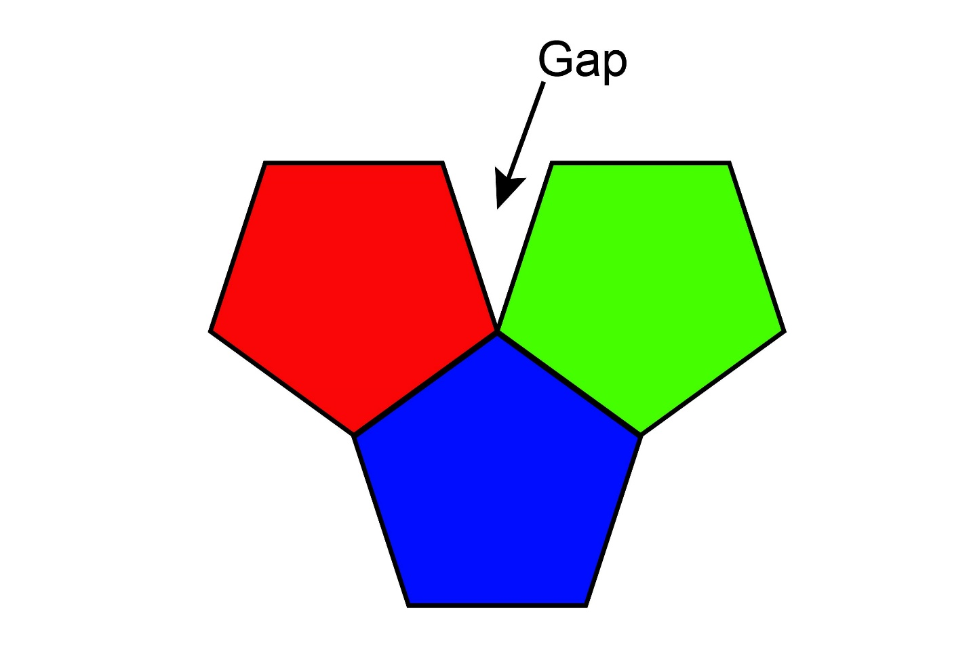
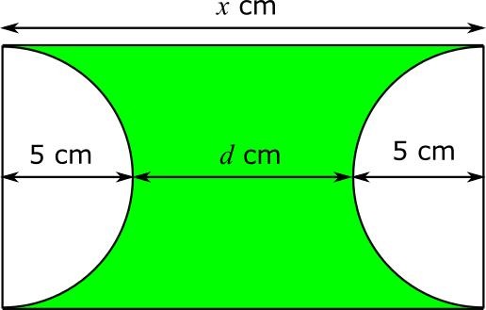
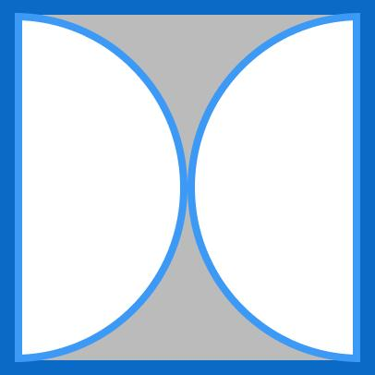

Purpose
# Source: AI Source: Provided by: [Data Path: Persons Table -> ID Column: 1, Name_En Column: Motasem Essam] -> From: [ChatGPT] on [7/25/2026]
A Region Gap is used to:
- Describe an empty area separating regions.
- Identify spaces between geometric objects.
- Measure the area of an empty region.
- Describe separation between non-touching regions.
- Analyze spacing and empty areas in geometric configurations.

Fundamental Concept
# Source: AI Source: Provided by: [Data Path: Persons Table -> ID Column: 1, Name_En Column: Motasem Essam] -> From: [ChatGPT] on [7/25/2026]
Consider two rectangular regions:
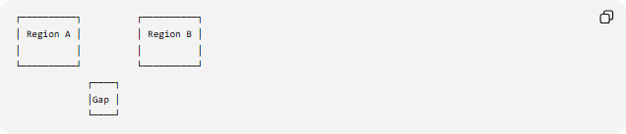
┌──────────┐ ┌──────────┐
│ Region A │ │ Region B │
│ │ │ │
└──────────┘ └──────────┘
┌────┐
│Gap │
└────┘
The space between the two regions is the Region Gap.
The gap may have a measurable:
- width
- length
- area
- shape
depending on the configuration.

Mathematical Representation
# Source: AI Source: Provided by: [Data Path: Persons Table -> ID Column: 1, Name_En Column: Motasem Essam] -> From: [ChatGPT] on [7/25/2026]
If $A$and $B$are two non-overlapping regions contained in a larger region $U$, the region between them can be represented conceptually as:
$$\boxed{G=U∖\left(A∪B\right)}$$
where $G$represents the remaining empty region within the specified surrounding region $U$.
The exact mathematical representation depends on how the surrounding region and the boundaries of the objects are defined.

Important Distinction
# Source: AI Source: Provided by: [Data Path: Persons Table -> ID Column: 1, Name_En Column: Motasem Essam] -> From: [ChatGPT] on [7/25/2026]
A Region Gap should not be confused with the distance between regions.
For example:
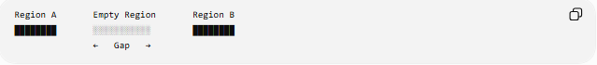
Region A Empty Region Region B
████████ ░░░░░░░░░░░ ████████
← Gap →
There are two different quantities:
$$\boxed{\text{Gap Size}}$$
which describes the empty region, and
$$\boxed{\text{Distance}}$$
which measures separation between selected boundaries or points.

Types of Region Gaps

1. Open Region Gap
# Source: AI Source: Provided by: [Data Path: Persons Table -> ID Column: 1, Name_En Column: Motasem Essam] -> From: [ChatGPT] on [7/25/2026]
The gap is an open space between two regions.
███████ ███████
Open Gap

2. Enclosed Region Gap
# Source: AI Source: Provided by: [Data Path: Persons Table -> ID Column: 1, Name_En Column: Motasem Essam] -> From: [ChatGPT] on [7/25/2026]
An empty region is completely surrounded by another geometric region or collection of boundaries.
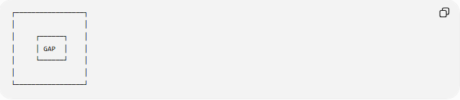
┌─────────────────┐
│ │
│ ┌──────┐ │
│ │ GAP │ │
│ └──────┘ │
│ │
└─────────────────┘

3. Linear-Shaped Region Gap
# Source: AI Source: Provided by: [Data Path: Persons Table -> ID Column: 1, Name_En Column: Motasem Essam] -> From: [ChatGPT] on [7/25/2026]
The empty region is narrow and elongated.
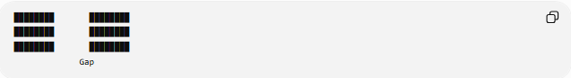
████████ ████████
████████ ████████
████████ ████████
Gap

4. Irregular Region Gap
# Source: AI Source: Provided by: [Data Path: Persons Table -> ID Column: 1, Name_En Column: Motasem Essam] -> From: [ChatGPT] on [7/25/2026]
The empty space has an irregular boundary.
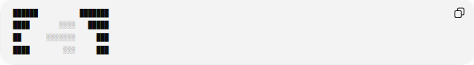
██████ ███████
████ ░░░░ █████
██ ░░░░░░░ ███
████ ░░░ ███

Region Gap Area
# Source: AI Source: Provided by: [Data Path: Persons Table -> ID Column: 1, Name_En Column: Motasem Essam] -> From: [ChatGPT] on [7/25/2026]
When the gap forms a measurable two-dimensional region, its size can be expressed as an area.
If the surrounding region has area $A_{U}$, and the occupied regions have areas $A_{1},A_{2},…,A_{n}$, with no overlaps, then:
$$\boxed{A_{G}=A_{U}-\sum_{i=1}^{n}{A_{i}}}$$
For two regions:
$$\boxed{A_{G}=A_{U}-A_{1}-A_{2}}$$

Example
# Source: AI Source: Provided by: [Data Path: Persons Table -> ID Column: 1, Name_En Column: Motasem Essam] -> From: [ChatGPT] on [7/25/2026]
Suppose a rectangular area has:
$$A_{U}=100{\text{ m}}^{2}$$
Two objects occupy:
$$A_{1}=30{\text{ m}}^{2}$$
and
$$A_{2}=25{\text{ m}}^{2}$$
Then the remaining gap area is:
$$A_{G}=100-30-25 \\ \boxed{A_{G}=45{\text{ m}}^{2}}$$

Region Gap vs. Boundary Gap
# Source: AI Source: Provided by: [Data Path: Persons Table -> ID Column: 1, Name_En Column: Motasem Essam] -> From: [ChatGPT] on [7/25/2026]
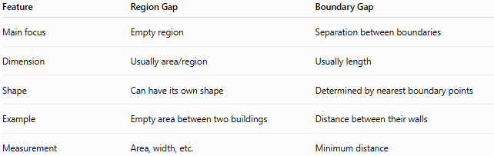
Feature | Region Gap | Boundary Gap
Main focus | Empty region | Separation between boundaries
Dimension | Usually area/region | Usually length
Shape | Can have its own shape | Determined by nearest boundary points
Example | Empty area between two buildings | Distance between their walls
Measurement | Area, width, etc. | Minimum distance
For example:
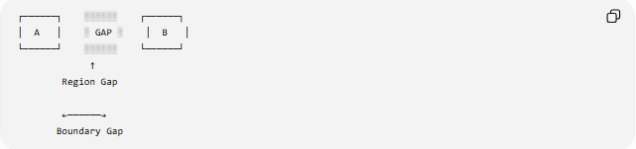
┌──────┐ ░░░░░░ ┌──────┐
│ A │ ░ GAP ░ │ B │
└──────┘ ░░░░░░ └──────┘
↑
Region Gap

←──────→
Boundary Gap
The Region Gap is the entire empty space, while the Boundary Gap can be its minimum width.

Region Gap vs. Linear Gap
# Source: AI Source: Provided by: [Data Path: Persons Table -> ID Column: 1, Name_En Column: Motasem Essam] -> From: [ChatGPT] on [7/25/2026]
A Linear Gap is fundamentally one-dimensional:
$$\boxed{\text{Linear Gap}→\text{length}}$$
A Region Gap is two-dimensional:
$$\boxed{\text{Region Gap}→\text{area}}$$
However, a region gap can also have a measurable width or minimum separation.

Zero Region Gap
# Source: AI Source: Provided by: [Data Path: Persons Table -> ID Column: 1, Name_En Column: Motasem Essam] -> From: [ChatGPT] on [7/25/2026]
If two regions completely meet without an intervening empty region, there is no positive Region Gap.
Conceptually:
$$\boxed{G=∅}$$
or:
$$\boxed{A_{G}=0}$$
depending on the mathematical context.

Positive Region Gap
# Source: AI Source: Provided by: [Data Path: Persons Table -> ID Column: 1, Name_En Column: Motasem Essam] -> From: [ChatGPT] on [7/25/2026]
If an actual empty region exists between the objects:
$$\boxed{G≠∅}$$
and, when it has measurable area:
$$\boxed{A_{G}>0}$$

Example: Rectangular Gap
# Source: AI Source: Provided by: [Data Path: Persons Table -> ID Column: 1, Name_En Column: Motasem Essam] -> From: [ChatGPT] on [7/25/2026]
Suppose two rectangular regions are separated by a rectangular empty space measuring:
$$8\text{ m}×3\text{ m}$$
The Region Gap has area:
$$A_{G}=8×3 \\ \boxed{A_{G}=24{\text{ m}}^{2}}$$
Its width can also be described as:
$$\boxed{3\text{ m}}$$
So the same Region Gap can have multiple measurable characteristics.

Relationship with Other Gaps
# Source: AI Source: Provided by: [Data Path: Persons Table -> ID Column: 1, Name_En Column: Motasem Essam] -> From: [ChatGPT] on [7/25/2026]
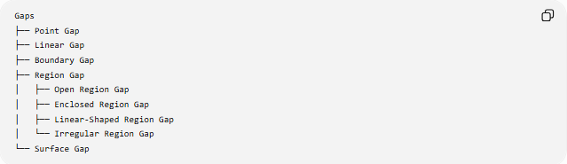
Gaps
├── Point Gap
├── Linear Gap
├── Boundary Gap
├── Region Gap
│ ├── Open Region Gap
│ ├── Enclosed Region Gap
│ ├── Linear-Shaped Region Gap
│ └── Irregular Region Gap
└── Surface Gap

Real-World Applications
# Source: AI Source: Provided by: [Data Path: Persons Table -> ID Column: 1, Name_En Column: Motasem Essam] -> From: [ChatGPT] on [7/25/2026]
Region gaps occur in:
- Architecture: open spaces between buildings.
- Urban planning: spaces between land-use regions.
- Construction: empty areas between structures.
- Computer graphics: empty regions between objects.
- Maps: unoccupied areas between mapped regions.
- Engineering: open spaces between components.
- Floor planning: unused spaces between designated areas.

Key Points
# Source: AI Source: Provided by: [Data Path: Persons Table -> ID Column: 1, Name_En Column: Motasem Essam] -> From: [ChatGPT] on [7/25/2026]
- A Region Gap is an empty region separating geometric regions.
- It focuses on the space itself, rather than only the distance between boundaries.
- It can have a measurable area:
$$\boxed{A_{G}}$$
- Its width or minimum separation can also be measured.
- A Boundary Gap measures boundary-to-boundary separation.
- A Region Gap describes the actual empty region.

Conclusion
# Source: AI Source: Provided by: [Data Path: Persons Table -> ID Column: 1, Name_En Column: Motasem Essam] -> From: [ChatGPT] on [7/25/2026]
A Region Gap is an empty geometric region that separates two or more regions. It is a two-dimensional form of gap and can be characterized by its shape, area, width, and boundary.
Would you like to continue with a surface gap or compare region gaps with boundary gaps?

